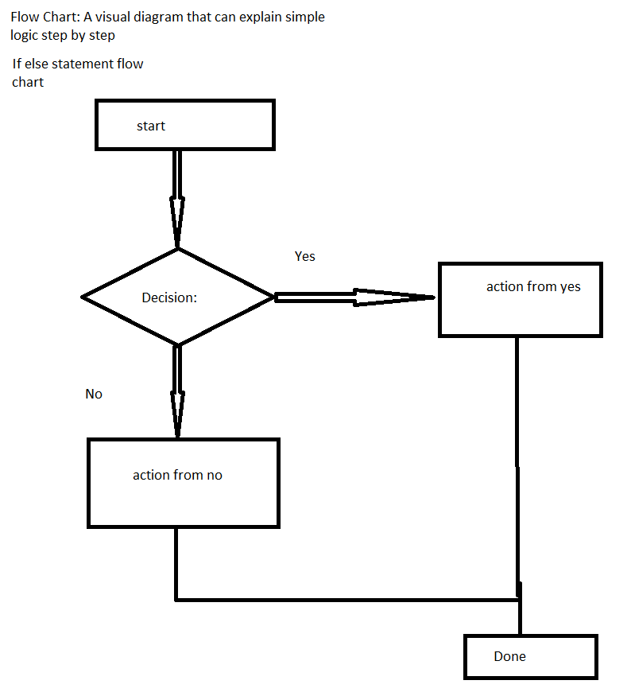
- Technically, you only need if
- If you are going to have two choices, you need the keyword else
- Please do not separate if and else
- If we have more than 2 choices, we need another keyword else if
- Else if →you need conditions
- Else if →you pick one and discards the rest
- Series of if statements→it will check every case
- Else if and else will follow to the closest if
- Remember, the code runs from top to bottom
- The computer will pick the right case, not necessarily the most correct case

